PAN PACIFIC MASTERS GAMES – PPMG26
THE STAR THEATRE, GOLD COAST
LIGHTING REFERENCE MENU
This menu uses the ACF Senior Club Team Carnival Lighting Reference Menu (Front, Wash, Motion and Foot Light, unchanged from the ACC26 menu) with The Star's own Gobo library substituted, plus Blinders and a Follow Spot available at this venue only. Only the cues listed below will be available — please do not request combinations or positions outside this menu.

Lighting Limits
- Maximum of 8 cues per item
- Final cue (cue 8) must be a blackout
- Preset is by default a blackout
- For each cue, list only what needs to be ON. Anything not listed in that cue will automatically turn OFF from the previous cue.

For Each Cue, Select:
- One or more Front (F) light positions
- Up to ONE Wash Colour (C)
- Up to ONE Gobo (S) — for S2–S8, also specify rotation speed: Static, Slow, Medium, or Fast
- Up to ONE Motion (M)
- Up to ONE Foot Light (L)
- Up to ONE Side Light colour (D), if required
- One or two Blinders (B) — P side, OP side, or both
- A Follow Spot (FS), if required for the item
Only the percentages listed in this menu are available — there is no in-between. If a chosen look reads too dark on the day, the venue's lighting technician may be asked to lift the front light, but only using white light.

Timing of cues
- Leave a minimum of TEN (10) seconds between cues.
- All cue changes take 1.5 seconds to complete once called.
- Haze will be on consistently throughout — no need for coaches to request it.
- Gobo Spots (S) can be used at the same time as Front Light (F) positions.

Front Light — select one or more per cue
F7, F8 and F9 are Upstage positions (corrected from the ACC26 menu, which mislabelled these as Downstage). All other Front Light codes and percentages are unchanged from ACC26. Photos are from the ACC26 Lighting Reference Menu, reused where the position/look is the same.
Code | Photo | Description
F1 | 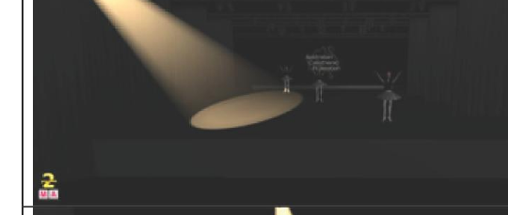 | Spot Downstage Right
F2 | 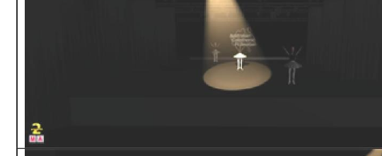 | Spot Downstage Centre
F3 | 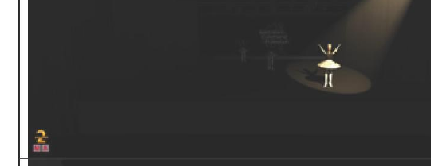 | Spot Downstage Left
F4 | 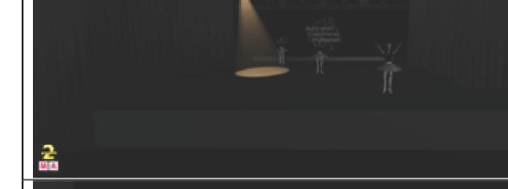 | Spot Centre Stage Right
F5 | 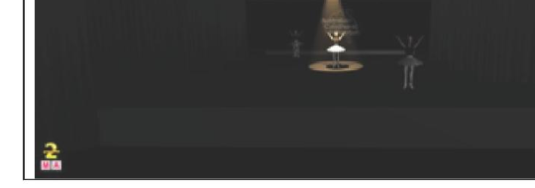 | Spot Centre Stage
F6 | 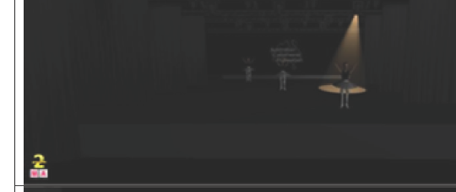 | Spot Centre Stage Left
F7 | 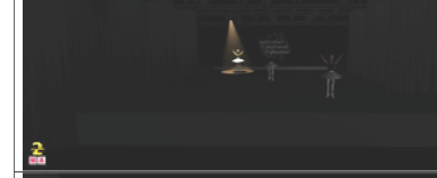 | Spot Upstage Right
F8 | 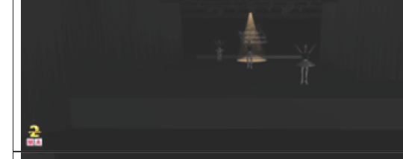 | Spot Upstage Centre
F9 | 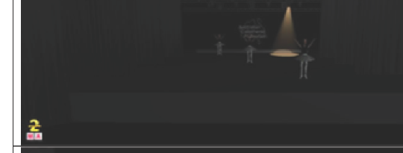 | Spot Upstage Left
F10 | 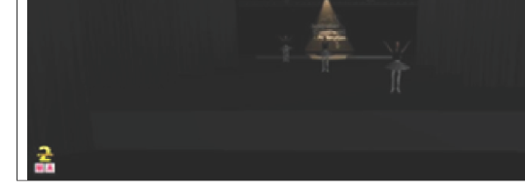 | Spot Centre Rear Platform
F11 | 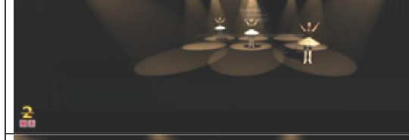 | Spot Nine Positions (1–9 together)
F12 | 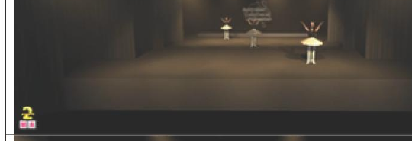 | Front Light at 100%
F13 | 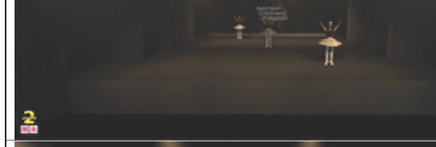 | Front Light at 75%
F14 | 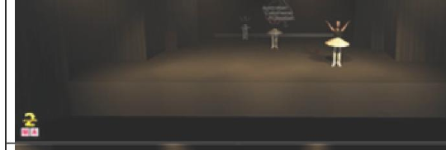 | Downstage Only Front Light at 100%
F15 | 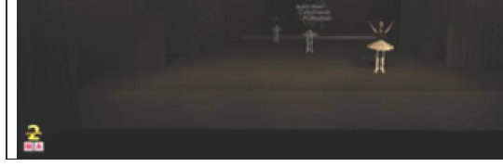 | Downstage Only Front Light at 75%
F16 | 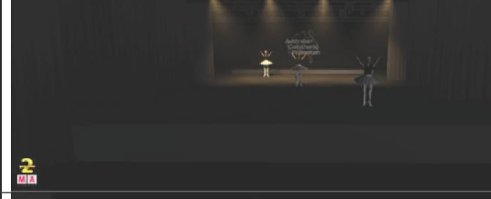 | Upstage Only Front Light at 100%
F17 | 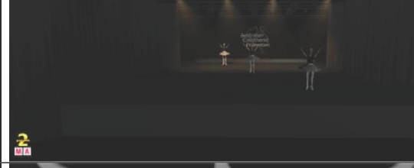 | Upstage Only Front Light at 75%
F18 | 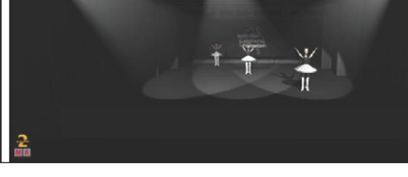 | Front Light at 100% – Pure White

Wash Colour — select up to ONE per cue
Photos are from the ACC26 Lighting Reference Menu.
Code | Photo | Colour
C1 | 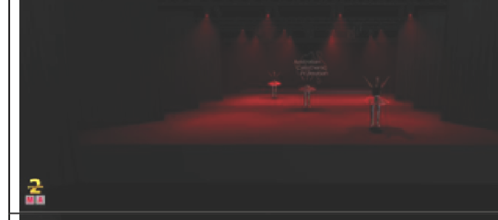 | Red
C2 | 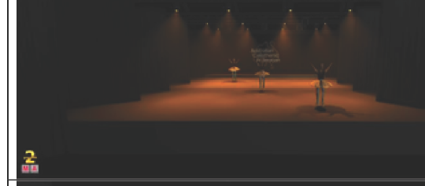 | Orange
C3 | 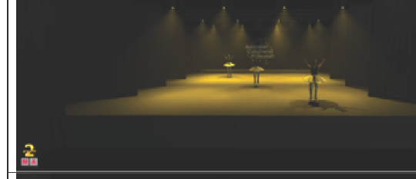 | Yellow
C4 | 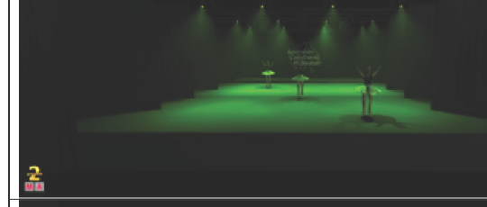 | Green
C5 | 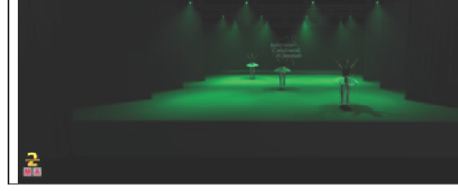 | Sea Green
C6 | 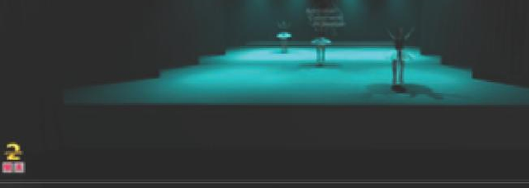 | Aqua (Cyan)
C7 | 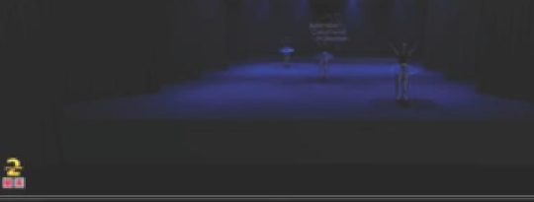 | Blue
C8 | 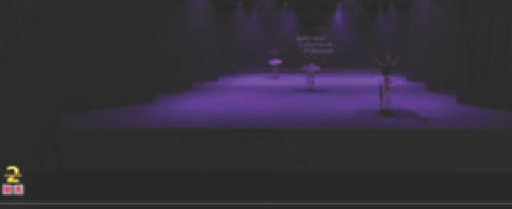 | Purple
C9 | 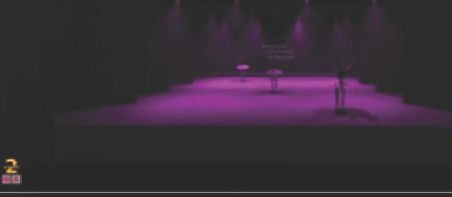 | Pink
C10 | 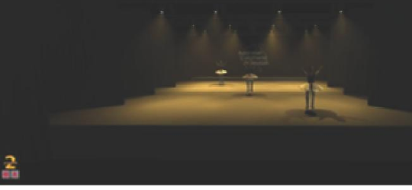 | Warm White
C11 | 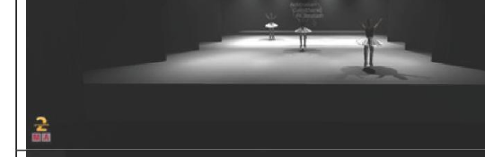 | Pure White

Gobo Spot — select up to ONE per cue
The Star's in-house gobo library, using The Star's own S1–S16 numbering (as supplied). Confirmed with venue: all gobos can be run static; S2–S8 can also rotate (slow, medium, or fast — specify which when selecting the code). S1 and S9–S16 are static only.
Code | Image | Description | Type
S1 | 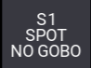 | No Gobo (open white) | —
S2 | 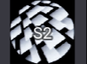 | Wide Lines | Static or Rotating (S/M/F)
S3 | 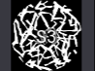 | Squiggles | Static or Rotating (S/M/F)
S4 | 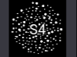 | Spots | Static or Rotating (S/M/F)
S5 | 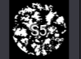 | Clouds | Static or Rotating (S/M/F)
S6 | 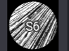 | Thin Lines | Static or Rotating (S/M/F)
S7 | 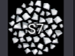 | Cosmic | Static or Rotating (S/M/F)
S8 | 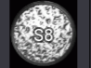 | Moon | Static or Rotating (S/M/F)
S9 | 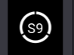 | Circle | Static
S10 | 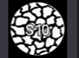 | Dry Mud (Terrain) | Static
S11 | 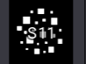 | Cubes | Static
S12 | 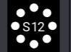 | Dots | Static
S13 | 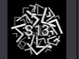 | Angles | Static
S14 | 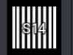 | Barcode | Static
S15 | 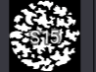 | Splots | Static
S16 | 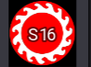 | Waves (Sunburst) | Static

Motion — select up to ONE per cue
Photos are from the ACC26 Lighting Reference Menu.
Code | Photo | Description
M1 | 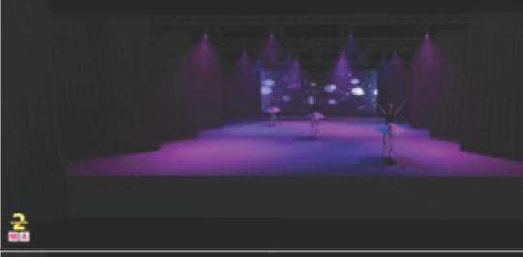 | Slow Purple to Blue Fade on Wash
M2 | 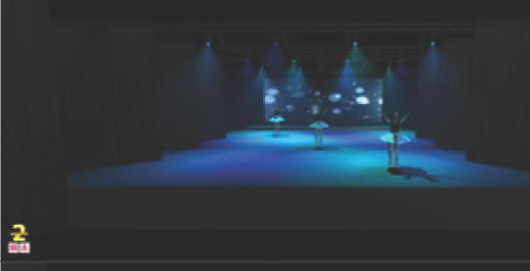 | Slow Light Blue to Blue Fade on Wash
M3 | 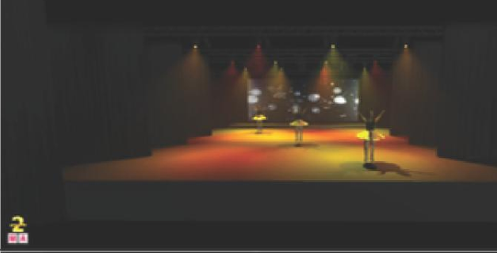 | Slow Red to Yellow Fade on Wash
M4 | 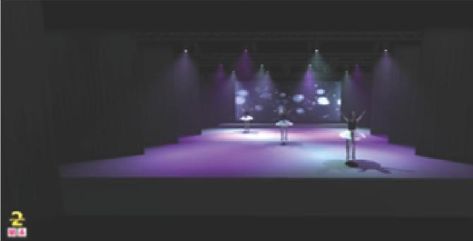 | Slow Purple to White Fade on Wash
M5 | 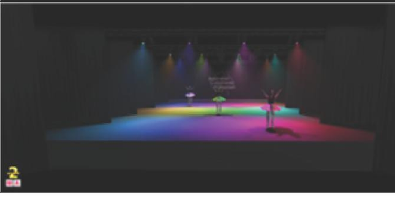 | Full Colour Chase – Random
M6 | 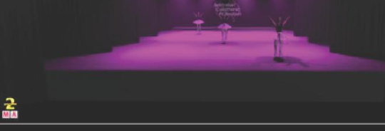 | Full Colour Chase – All Lights Changing Colour at the Same Time
M7 | 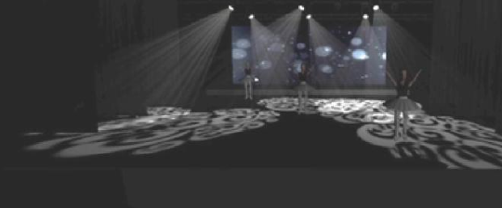 | Slow Pan Movement on Gobo Spots
M8 | 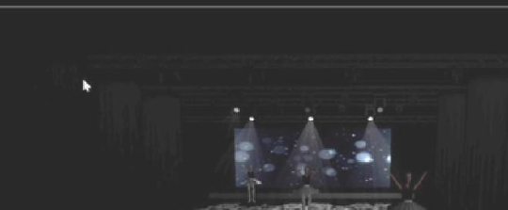 | Slow Dim on Gobo Spots

Foot Light — select up to ONE per cue
Photos are from the ACC26 Lighting Reference Menu. Any Foot Light colour can be requested at 75% or 100% intensity — specify the percentage when selecting a code.
Code | Photo | Colour
L1 | 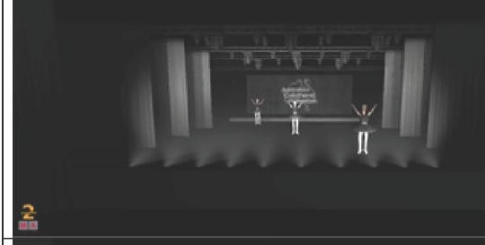 | Pure White
L2 | 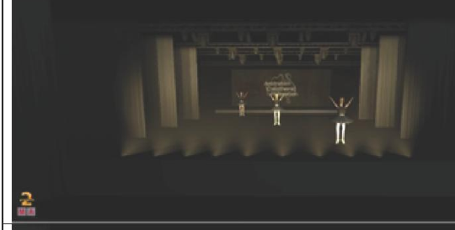 | Warm White
L3 | 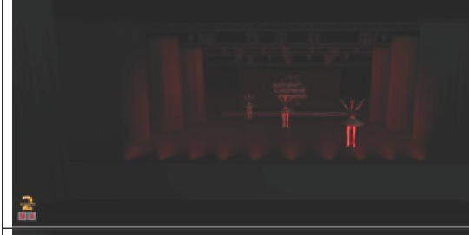 | Red
L4 | 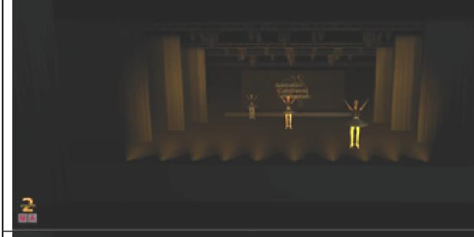 | Orange
L5 | 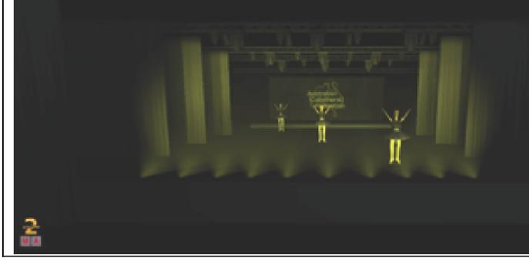 | Yellow
L6 | 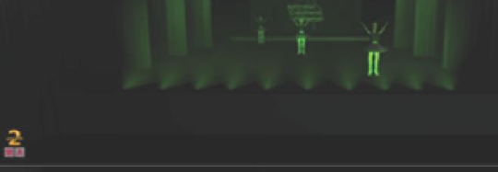 | Green
L7 | 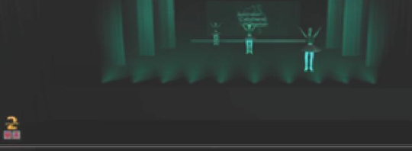 | Sea Green
L8 | 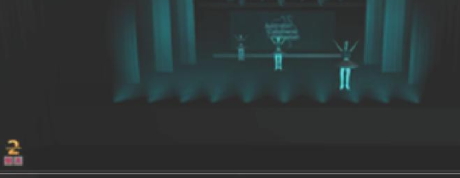 | Aqua
L9 | 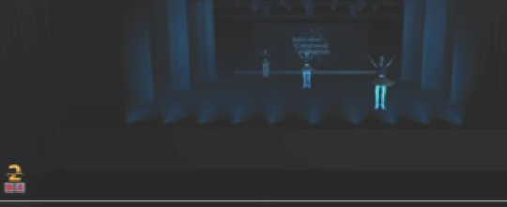 | Blue
L10 | 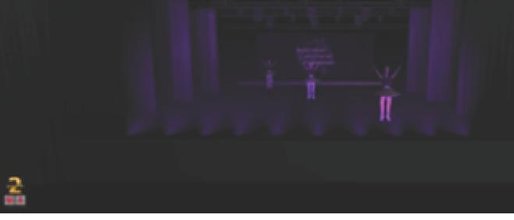 | Purple
L11 | 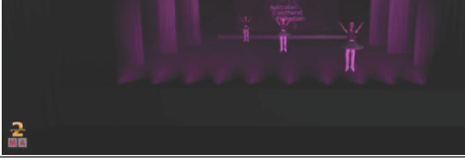 | Pink

Blinders — add one or two per cue (Star only)
Blinders face the audience — select the Prompt (P) side, Opposite Prompt (OP) side, or both together.
Code | Description
B1 (P) | Single Blinder – Prompt (P) Side
B1 (OP) | Single Blinder – Opposite Prompt (OP) Side

Side Light — select up to ONE per cue (Star only)
No photos available for these codes yet.
Code | Colour
D1 | White
D2 | Warm White
D3 | Red
D4 | Orange
D5 | Yellow
D6 | Green
D7 | Sea Green
D8 | Aqua
D9 | Blue
D10 | Purple
D11 | Pink

Follow Spot (Star only)
Available on request. The Star's lighting team will operate the follow spot — clubs/teams do not need to supply their own operator.
Code | Description
FS | Follow Spot — operated by The Star's lighting team on request

