PAN PACIFIC MASTERS GAMES – PPMG26
BROADBEACH CULTURAL CENTRE
LIGHTING REFERENCE MENU
Broadbeach Cultural Centre has a basic in-house lighting rig — a full stage colour wash and a set of gobos. There is no Front Light plot Motion, Foot Light, Blinders or Follow Spot at this venue. Only the cues listed below will be available.

Lighting Limits
- Maximum of 8 cues per item
- Final cue (cue 8) must be a blackout
- Preset is by default a blackout
- For each cue, list only what needs to be ON. Anything not listed in that cue will automatically turn OFF from the previous cue.

For Each Cue, Select:
- Up to ONE Wash Colour (C)
- Up to ONE Gobo (S)
Only the percentages listed in this menu are available — there is no in-between. If a chosen look reads too dark on the day, the venue's lighting technician may be asked to lift the facelight, but only using white light.

Timing
- Leave a minimum of TEN (10) seconds between cues.
- All cue changes take 1.5 seconds to complete once called.

Venue notes: stage is 10.7m deep x 10m wide. There is no back curtain to enter or exit the stage. Spotlights are not available.

Wash Colour — select up to ONE per cue
Colours available on Broadbeach's in-house fixture (combined from its two colour wheels). Photos are from the ACC26 Lighting Reference Menu, used where the colour is the same or closest match — Broadbeach's own fixture may render slightly differently.
Code | Photo | Colour
C1 | 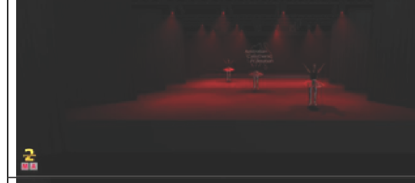 | Red
C2 | 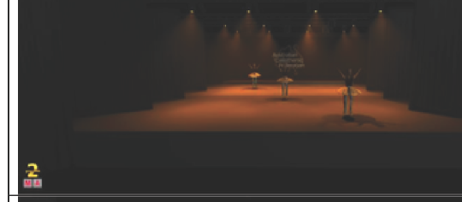 | Orange
C3 | 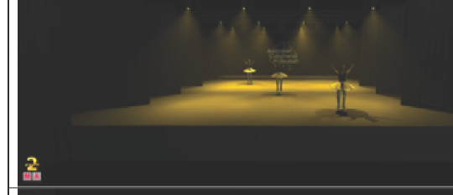 | Yellow
C4 | — | Dark Yellow (Amber) — no ACC26 equivalent photo
C5 | 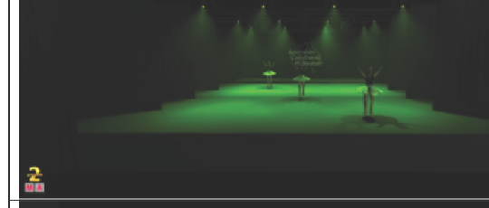 | Green
C6 | 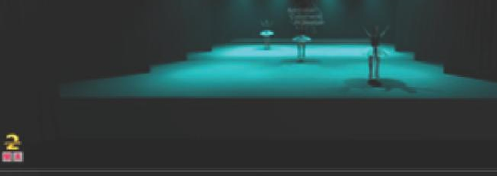 | Light Blue (closest match shown: Aqua)
C7 | 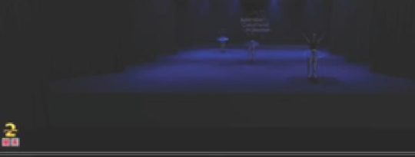 | Dark Blue
C8 | 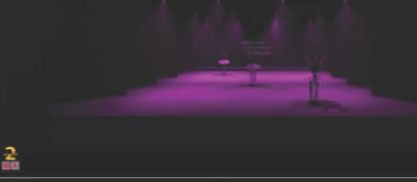 | Magenta / Pink
C9 | 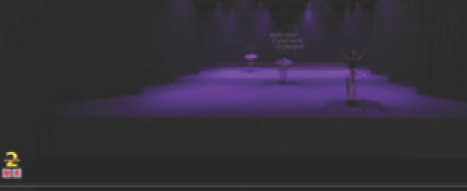 | UV / Purple
C10 | 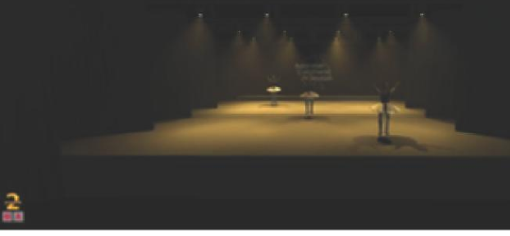 | Warm White (3200K)
C11 | 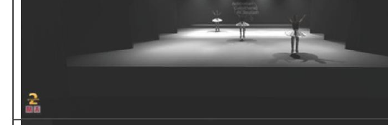 | Cool White (5600K)

Gobo Spot — select up to ONE per cue
Broadbeach's in-house gobo library — Static (fixed) and Rotating (indexing) wheels.
Code | Image | Description | Type
S1 | 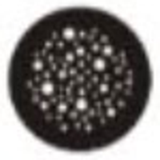 | Dots Breakup | Static
S2 |  | Bricks | Static
S3 |  | Triangle Rays | Static
S4 |  | Grouped Ovals | Static
S5 | 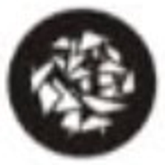 | Triangle Breakup | Static
S6 | 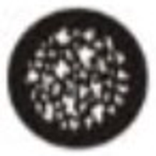 | Foliage Breakup | Static
S7 |  | Circle Dot | Static
S8 | 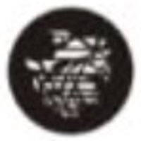 | Mosaic Breakup | Static
S9 | 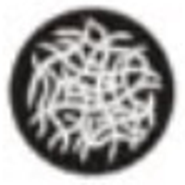 | Tribal Breakup | Rotating
S10 | 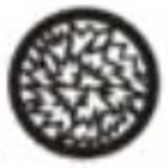 | Shattered | Rotating
S11 | 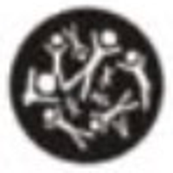 | Stickmen | Rotating
S12 | 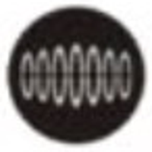 | Linear Ovals | Rotating
S13 |  | Laser Triangle | Rotating
S14 |  | Line | Rotating
S15 | 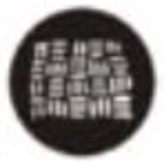 | Thatched Breakup | Rotating

