PAN PACIFIC MASTERS GAMES – CALISTHENICS 2026
myStage Upload & Lighting Submission Guide
⏰ DEADLINE EXTENDED — MIDNIGHT, SUNDAY 27 SEPTEMBER 2026
This is a final extension for lighting uploads only. No further extensions will be granted.

Can't Log In?
Use the same email address you registered your entries with — this is what myStage matches your account against.
- If you can't get in, use “Password Reset” on the myStage login page first.
- If that doesn't work, contact myStage directly (info@myStage.net.au) as a matter of urgency — don't wait until the deadline.
ACF cannot help with myStage logins — all entries are 100% managed within myStage, so this needs to go to myStage support directly.

Step 1: Log In
Log in to myStage using your registered email address.

Step 2: Complete Pre-Registration
Before the Lighting Cues section will let you enter anything, you need to complete pre-registration for each item. If you have pre-registration tasks outstanding, you'll see a “Competitor Pre-Registration Required” banner on your myStage home page.
- Click Pre-Register All to handle every competitor and item at once, OR
- Go to Competitors > [competitor name] and work through each item individually.
For each item, you'll be asked to upload your Music/DLP file (MP3 for audio, MP4 for DLP/video). Tick “All information complete for item” once you're done.
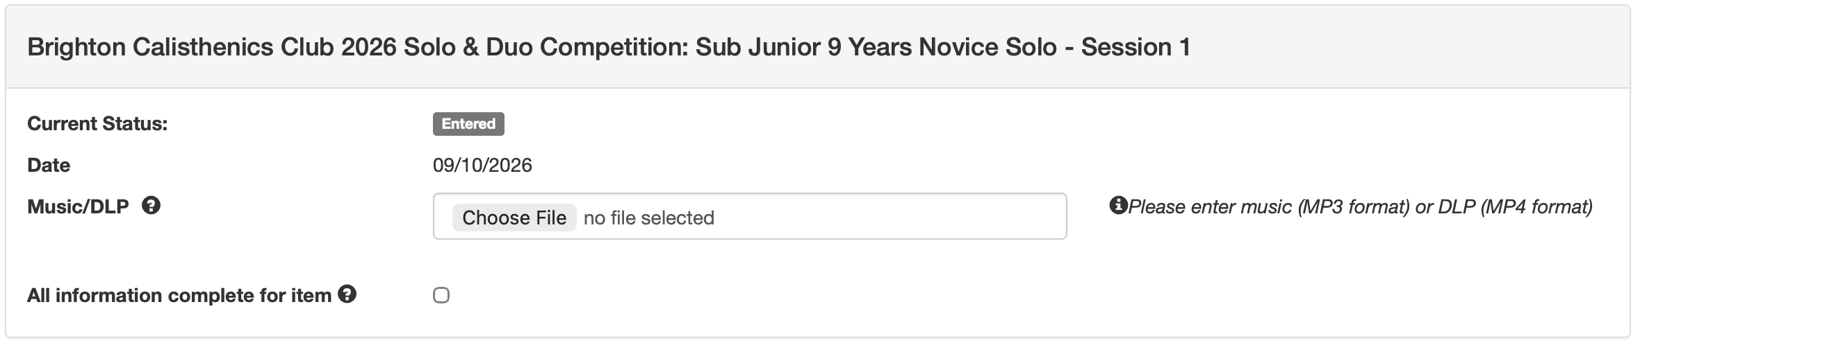
Example pre-registration form — upload Music/DLP and tick “All information complete for item”.
This step comes first. The Lighting Cues template for an item will not appear until pre-registration (including your Music/DLP upload) is marked complete for that item.

Step 3: Go to Lighting Cues
Once pre-registration is done, go to Competitor > Lighting Cues. You'll see a list of your sections — each shows a status of Incomplete or Complete. Click into a section (or use Edit Lighting Cues) to open its Lighting Sheet.
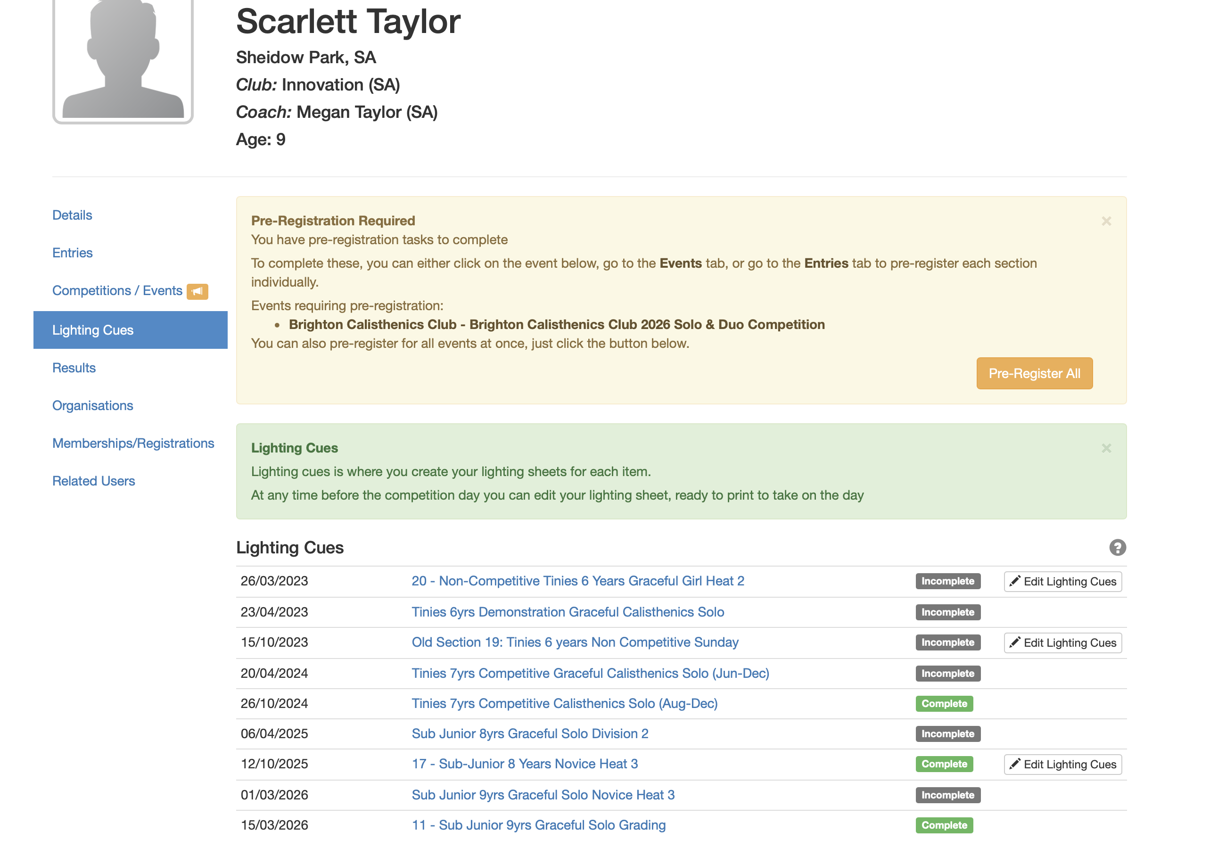
The Lighting Cues list for a competitor, showing status per section.

Step 4: Fill In the Lighting Sheet
For each cue, type the codes that need to be turned ON. Only list what should be ON — anything not listed will automatically turn off from the previous cue.
Format each cue with the codes on the top line, and suggest adding a plain-English description underneath (technicians will use the CODES however it is safest to also list the description for them to double check and for you to remember what lighting you used in each cue)
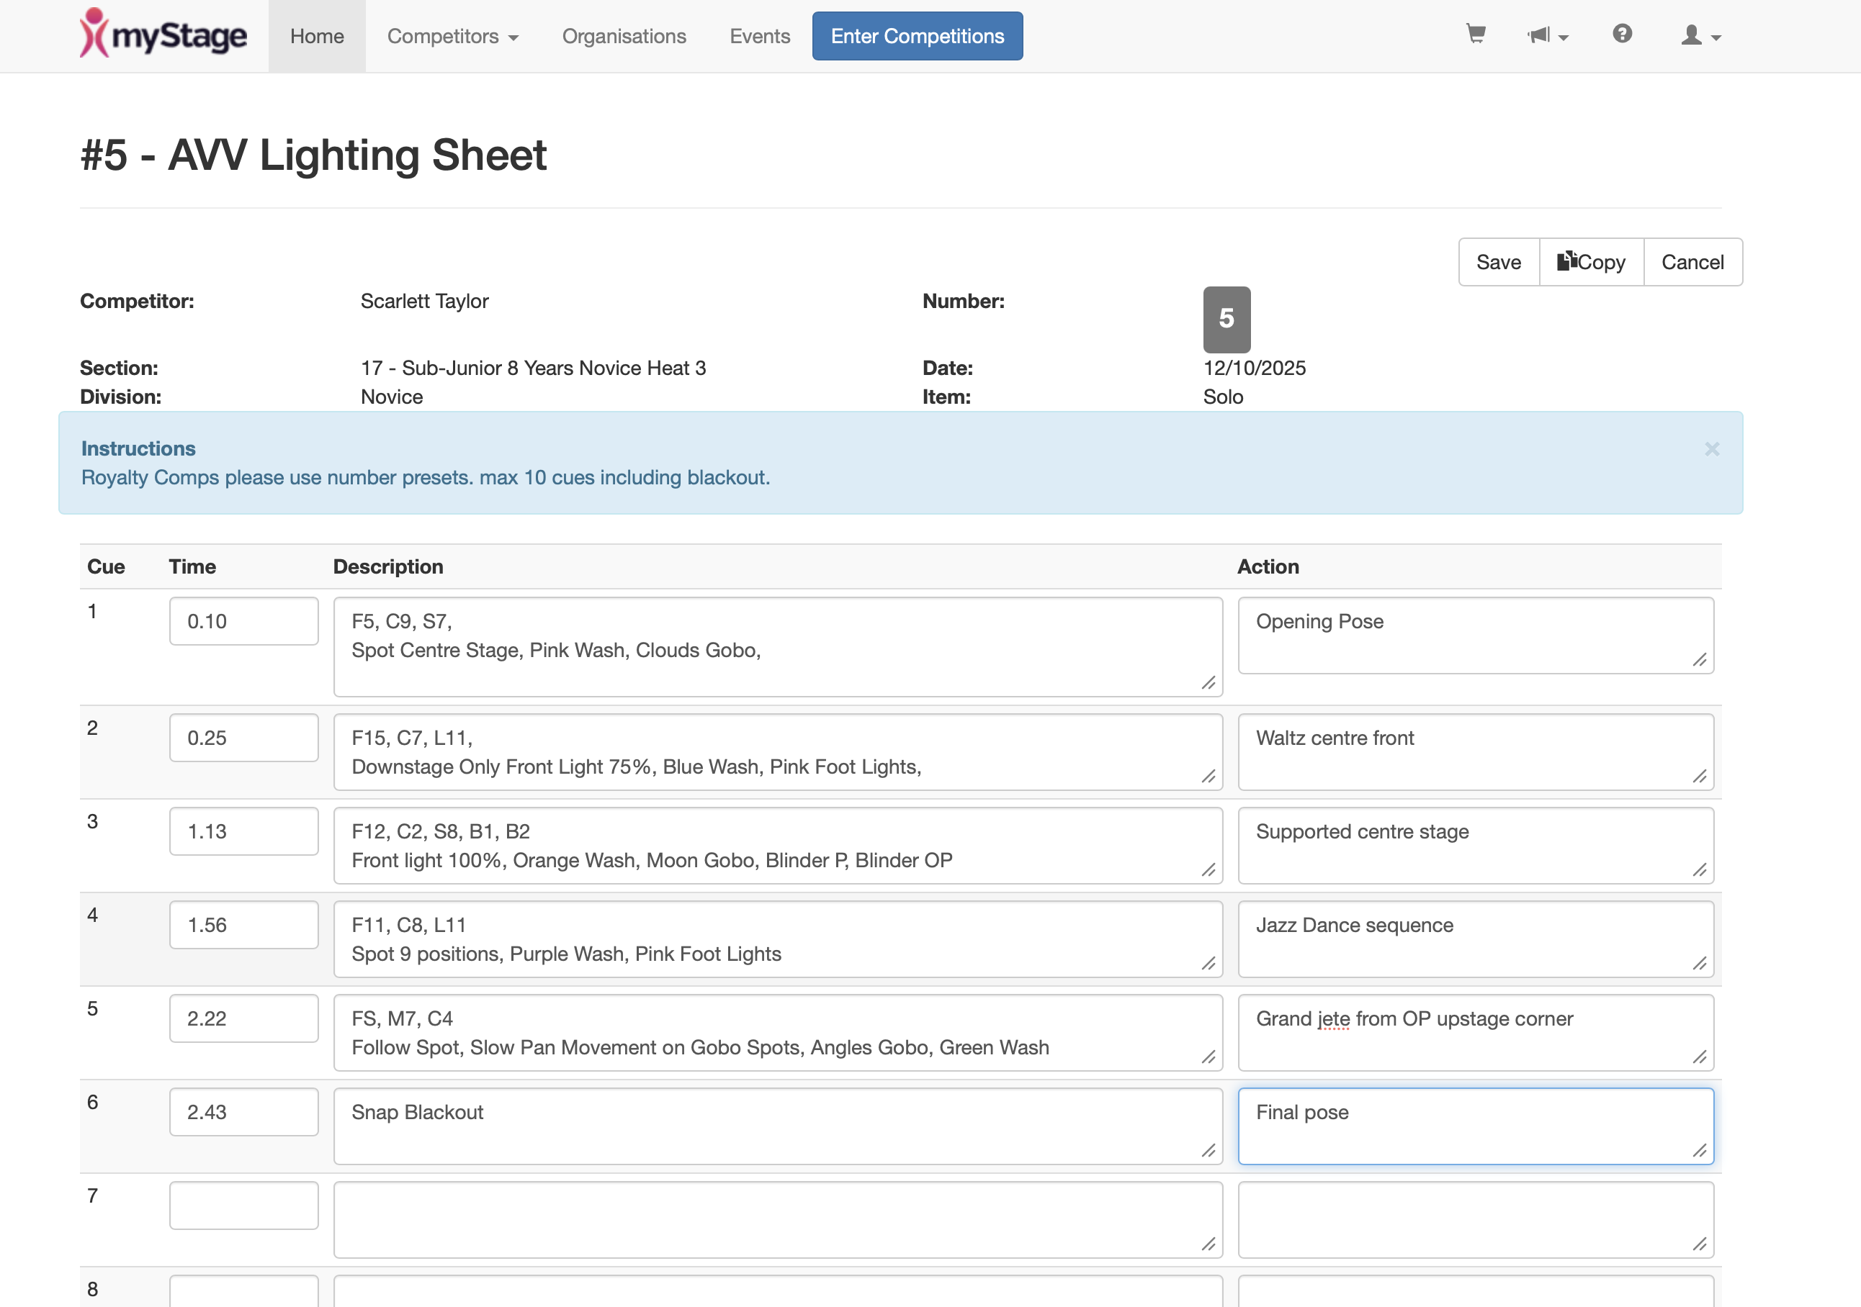
Example completed lighting sheet — codes on the top line, plain description underneath, Action column used as a coach's cue-calling prompt.

Timing on the Lighting Sheet
- Leave a minimum of TEN (10) seconds between cues.
- All cue changes take 1.5 seconds to complete once called.
The Time column is for YOUR use as coach — to help you rehearse and stay on track. Lighting technicians do NOT run cues off these times. They will only change a cue on your live command: “Standby cue 1”, then “Cue 1, GO”.
Use the Action column as a prompt for yourself (the coach) — a short note on what's happening in the routine at that point, so you know exactly when to call the next cue (e.g. “Opening Pose”, “Grand jete from OP upstage corner”).
The final cue must be a Blackout.
You will be calling your own music and lighting live during your item — see “Calling Cues on the Night” below for exactly how.

Calling Cues on the Night
You (the coach) are responsible for cueing your own music and lighting live during your item. A few pointers borrowed from the General Competition Etiquette for Coaches guide:
- Standby your cue at least 10 seconds in advance: “Standby cue 1”.
- Call it clearly when ready: “Cue 1, Go”.
- Speak calmly at a normal volume — headset microphones are highly sensitive.

Adding a Related User (Coach, Competitor or Parent)
If you'd like someone else to help with uploads or future entries, you can add them to your myStage account as a related user:
1. Select Competitor / [Name].
2. Go to Related Users.
3. Select New and add their details.
4. An invite will be sent to the new related user automatically.

Further Help from myStage
If it's easier to follow myStage's own instructions:
Pre-Registration Guide — docs.mystage.net.au/users/comp-preregistration
Adding a Related User — docs.mystage.net.au/users/related-user

